Worlds University Debating Championships 2004
Tab software (Beta version) User Guide

- Go to the tab homepage: http://cooldude:9000/worlds (Authentication required)
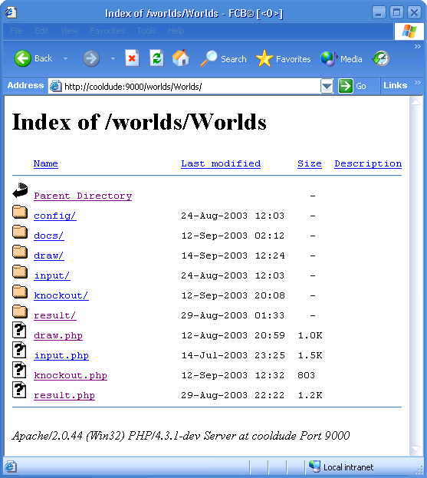

- First need to register the universities, teams and adjudicators and setup the venues. This is done at the ‘input.php’ page.
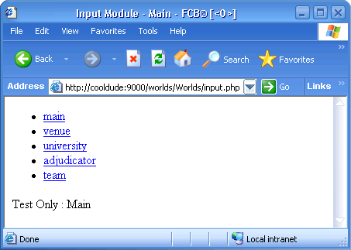

INPUT MODULE

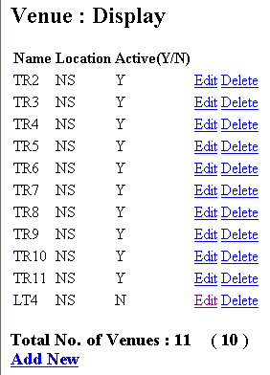
- Venue Setup: Click on ‘venue’. This will list out all the venues currently setup.

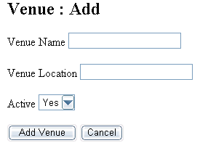
- A new Venue can be added by clicking the ‘Add New’ link at the bottom of the page.

Note: All the fields here are compulsory and can not be left empty. By default, the venue is set to be active.

Note: Only ‘Active’ venues will be assigned debates while creating the draws.

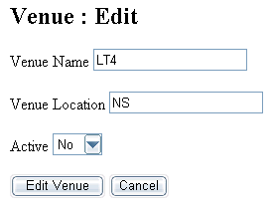
- The details of each existing venue can be changed by clicking on the ‘Edit’ link next to the venue. The following properties will come up.

- Any venue can also be deleted from the system by using the ‘Delete’ option. However, it is suggested that you change the Active status to ‘No’ rather than delete it.

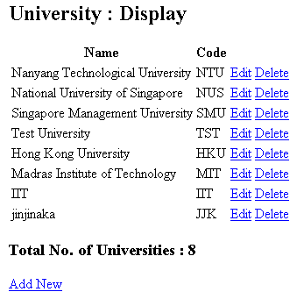
- The ‘University’ link on the input page allows you to setup the university information. The universities are setup in same manner as the venues above.

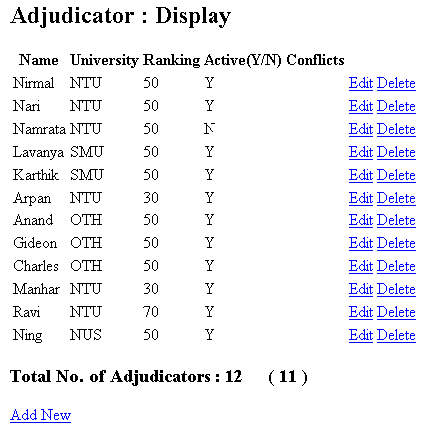
- The ‘Adjudicator’ link is to setup the tournament’s adjudicators. (Setup similar to above)

Note: The ‘Ranking’ column is to allow the tournament’s chief adjudicator to rate each of the adjudicators on a scale of 0 to 100. Adjudicators with higher ratings are assigned as ‘Chairs’ in the debates.

Note: The ‘Conflicts’ column allows the Chief Adjudicator to assign mention the universities that the adjudicator may have conflicts with. The tab software will by default not assign the adjudicator to any debate involving the teams mentioned here.

- The ‘Team’ option is to setup each team details including the participant details.
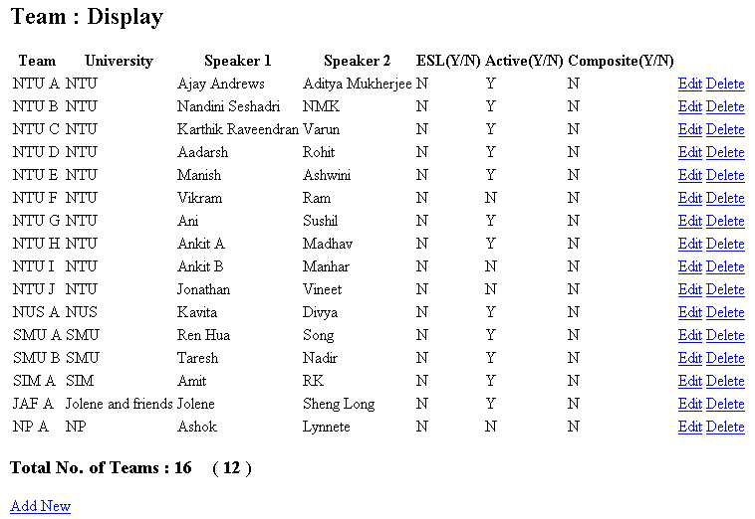
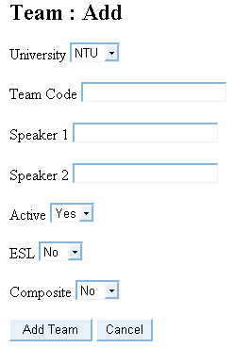
- While adding a new team, you will have to give the team a team code which has to be a single alphabet.

DRAW MODULE

- To create the draws, click on ‘draw.php’. As per the tournament rules, the generation of draws of Round 1 is quite different from those of other draws.

- Upon entering the ‘draws’ page for the 1st time (before Round 1), you will see a similar page:
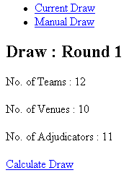
- Click on ‘Calculate Draw’ to generate a completely random draw.
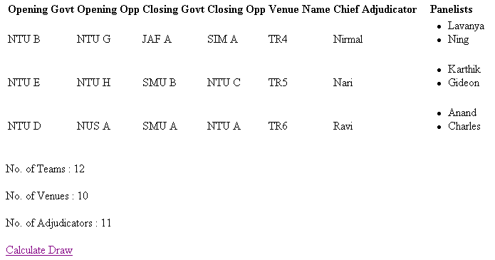
Note: You can use ‘Calculate Draw’ to create the draw again if there is any major change with the setup details for this round

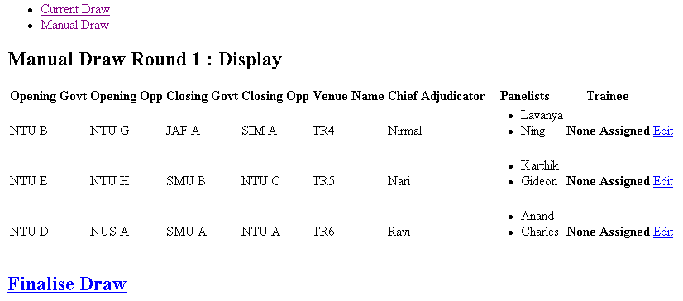
- Once the basic draw has been accepted by the Tournament Directors, click on ‘Manual Draw’ on top of the page

- This page allows the Chief Adjudicator to make changes to the Adjudicator assignment by clicking on the ‘Edit’ option adjacent to the debate he wishes to modify. Click on the ‘Modify Allocation’ button once completed.
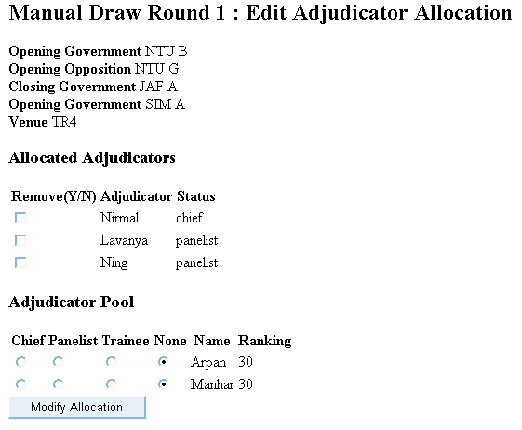
Note: This page shows the ‘Free Adjudicator Pool’ from where adjudicators can be assigned to this debate. The existing adjudicators can also be removed from the debate.

- Click on ‘Finalise Draw’ on the Draws page to confirm the draw for this round.


- Draws for other rounds are created in the same manner. However, when you enter the ‘draws.php’ page, you will find all the previous rounds listed at the top of the page.

- Click on ‘Current Round’ and continue as above.

RESULTS MODULE

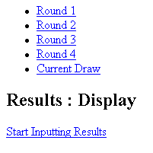
- From the homepage click the ‘Results’ option. You will see a page similar to the one below which also lists the completed rounds.

- If the draws have been generated already, click on ‘Current Draw’ and then click on ‘Start Inputting Results’. You should see.
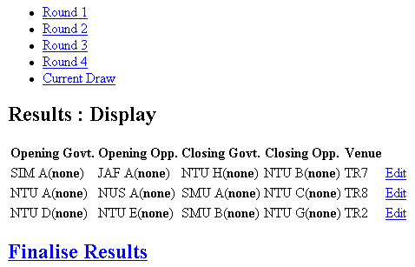

- Locate the debate you wish to enter the results for and click on the ‘Edit’ adjacent to it.
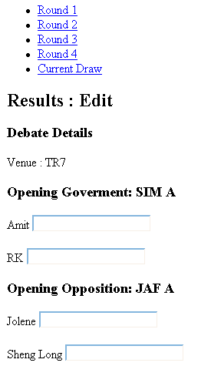
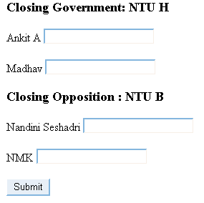

- Key in the speaker points for each speaker and click on ‘Submit’. The next page will show you the positions that each team has secured in the debate.
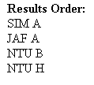


- Click on ‘Confirm’ if the scores entered are correct, else click on ‘Back’ to correct the scores.

- Similarly complete for all debates and then click on ‘Finalise Results’.
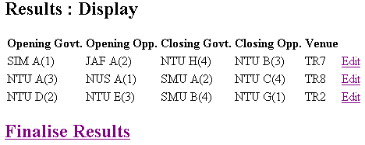

STANDINGS MODULE

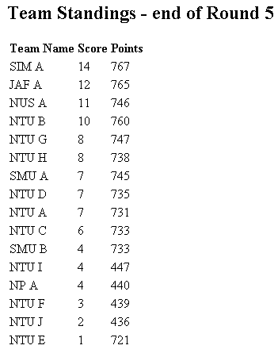
- From the homepage click on ‘knockout.php’. This will take you to the page that displays the standings.

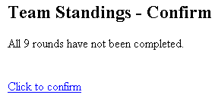
Note: In case you get any warnings as shown below, please read and ‘confirm’ that you have read and understood the warning

Debating Tournament (Worlds Style) Tab Software
Developed for WUDC 2004, NTU

Developers:
Deepak Jois
Aditya Krishnan

